SRM ARTS AND SCIENCE COLLEGE-KATTANKULATHUR

DEPARTMENT OF ELECTRONICS AND COMMUNICATION SCIENCE

ESTIMATION OF BUSINESS EXPENSES

**TEAM MEMBERS**

**1.MOHAMED ASFAR IBRAHIM N.M**

**2. VAMSI M.R**

**3. LOKRANJAN .B**

**4. MOHAMED AADHIL . A**

**TABLE OF CONTENT**

1. **INTRODUCTION**
   1. OVERVIEW
   2. PURPOSE
2. **PROBLEM DEFINITION & DESEIGN THINKING**
   1. EMPATHY MAP
   2. IDEATION & BRAINSTORMING MAP
3. **RESULT**
4. **ADVANTAGES & DISADVANTAGES**
5. **APPLICATIONS**
6. **CONCLUTION**
7. **FUTURE SCOPE**

**1.INTRODUCTION**

1.1 OVERVIEW

Estimation in business refers to the value or quantity of something that is

approximate and not exact. It is a statement or calculation of expected costs,

revenues, or profits. In business, an estimate is based on past experience and

knowledge of current trends.

1.2 PURPOSE

**2.PROBLEM DEFINITION & DESEIGN THINKING**

2.1 EMPATHY MAP

The use of estimates can be seen in different situations and across Indian industries.

Estimates are popular among businesses of all sizes and supply chain levels, such as

manufacturers, wholesalers, retailers, or other intermediaries. However, estimates are

most commonly used in project-based jobs such as construction, design, contracting, etc.2.1 BRAINSTROMING MAP

**3.RESULT**

• To get quotes in a market for a particular product or service.

• Estimates represent sales orders.

• Allows prepayments or deposits or retainers

.

• Acts as a document for collecting the approval of the buyer to go ahead with an

order

• A change in any of the details does not require

revision of the estimate or is not a final sales

invoice..

**Season wise production**

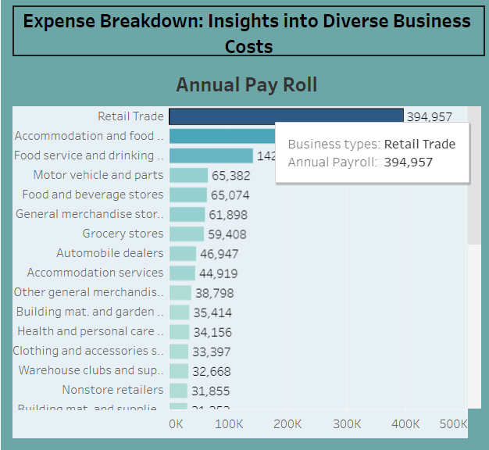

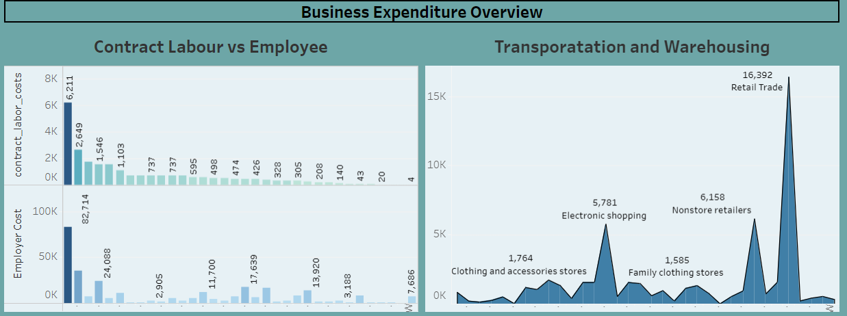

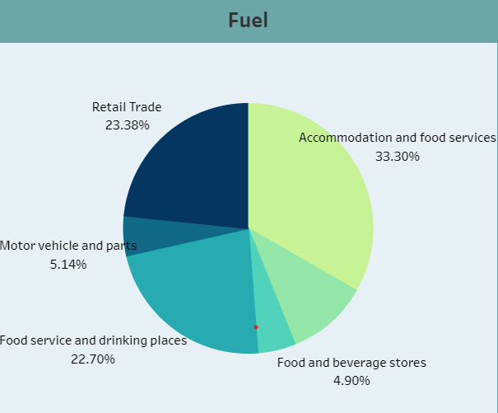

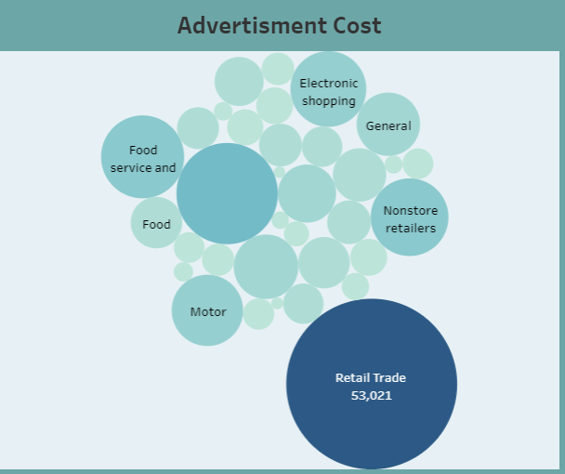

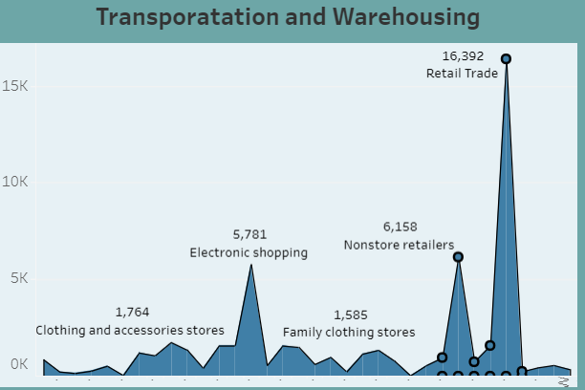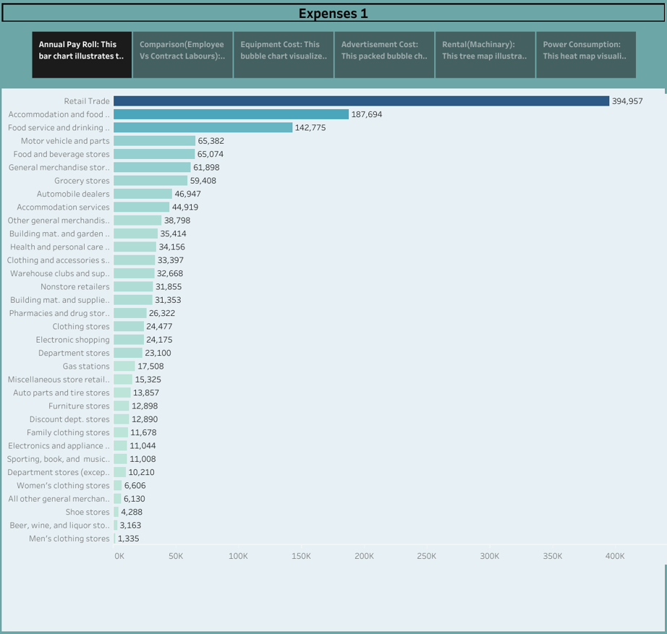

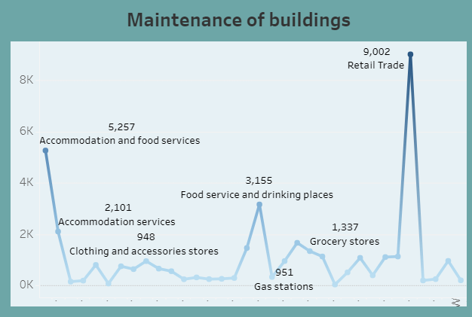

**4.ADVANTAGES AND DISADVANTAGES**

• The word ‘Estimate’ or ‘proforma invoice’ must be mentioned as the document’s

header.

Seller’s business name, logo, address, tax identification number, and contact details.

Corresponding details of the buyer or customer or business receiving the estimate.

The date of issuing the estimate.

The list of items offered with quantities available for supply.

Estimated rate and price for every item of goods or service offered.

**5.APPLICATIONS**

Producing accurate estimates is one of the most important aspects of job

management and key to successfully executing projects.

Not only are estimates essential to winning new business, they also determine

your project budget, your job schedule, and how you manage your resources,

and ultimately, how much you invoice clients.

**6.CONCLUSION**

As we have seen, cost is a complex subject that reaches far beyond the individual budget of any given

project. Different areas of the company use cost information in different ways, and the information must

be formulated to suit the company area that it serves.

When project managers are planning a project, and in particular are creating a project budget,

knowledge of the different kinds of costs that the project will incur is essential to successful budgeting.

In addition, an understanding of overall cost at a particular company in a specific industry will help

project managers create budgets that take cost into proper consideration and deliver winning results.

**7.FUTURE SCOPE**

As we have seen, cost is a complex subject that reaches far beyond the individual budget of any given

project. Different areas of the company use cost information in different ways, and the information must

be formulated to suit the company area that it serves.

When project managers are planning a project, and in particular are creating a project budget,

knowledge of the different kinds of costs that the project will incur is essential to successful budgeting.

In addition, an understanding of overall cost at a particular company in a specific industry will help

project managers create budgets that take cost into proper consideration and deliver winning results.

Improve the accuracy of cost, schedule, and resource estimates

Define a baseline for performance measurement and control

Facilitate clear responsibility assignments